

PROJECT TITLE: TRAVEL WEBSITE

SUBMITTED BY:

1. MRITUNJAY JHA ROLL NO=B36 REG NO=11906046

2. ADABALA CHAITANYA SATYA VAMSI KRISHNA ROLL NO=A34 REG NO=11902593

3.KRISHNA TEJA SANISETTY ROLL NO=A35 REG NO=11902461

**Project Report of Travel Website**

**Introduction of the Project Travel Website:**

The "Travel Website" has been developed to override the problems prevailing in the practicing manual system. This software is supported to eliminate and in some cases the hardships faced by this existing system. Moreover this system is designed for the particular need of the company to carry out operations in a smooth and effective manner.

The application is reduced as much as possible to avoid errors while entering the data It also provides error message while entering invalid data. No formal knowledge needed for the user to use this system. Thus by this all it proves it is user friendly Travel Website, as described above, can lead to error free, secure, reliable and fast management system. It can assist the user to concentrate on their other activities rather to concentrate on the record keeping. This it will help organization in better utilization of resources.

SYSTEM DESIGN

System design is the solution to the creation of a new system. This phase is composed of several systems. This phase focuses on the detailed implementation of the feasible system. It emphasis on translating design specifications to performance specification. System design has two phases of development logical and physical design.

**User Interface Design**

User Interface Design is concerned with the dialogue between a user and the computer. is concerned with everything from starting the system or logging into the system to the eventually presentation of desired inputs and outputs. The overall flow of screens and messages is called a dialogue The following steps are various guidelines for User Interface Design:

1. The system user should always be aware of what to do next

2. The screen should be formatted so that various types of information instructions and messages always appear in the same general display area.

3. Message instructions or information should be displayed long enough to allow the system user to read them.

4. Use display attributes sparingly

5. Default values for fields and answers to be entered by the user should be

PURPOSE OF WEBSITE

The purpose of Travel Website is to automate the existing manual system by the help of computerized equipments and full-fledged computer software, fulfilling their requirements so that their valuable data information can be stored for a longer period with easy accessing and manipulation of the same. The required software and hardware are easily available and easy to work with

Travel Website, as described above, can lead to error free. secure, reliable and fast management system. It can assist the user to concentrate on their other activities rather to concentrate on the record keeping. Thus it will help organization in better utilization of resources. The organization can maintain computerised records without redundant entries. That means that one need not be distracted by information that is not relevant, while being able to reach the information.

HOME PAGE

The home page of a website is the first page that a user perceives upon entering the website url at the browser address area. The entire website depends on how the home page is designed which forms the platform for viewing other web forms. In short, a home page forms the abstract of the entire website.

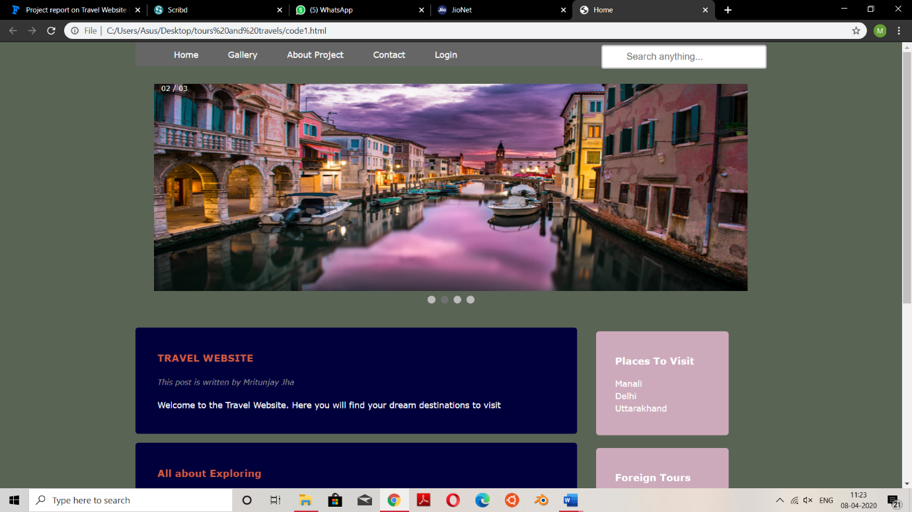

GALLERY

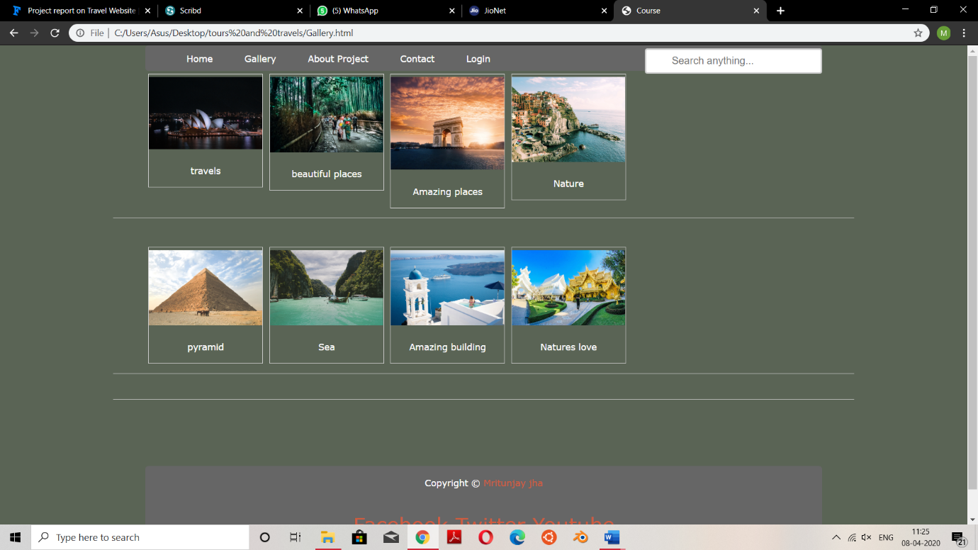

CONTACT US

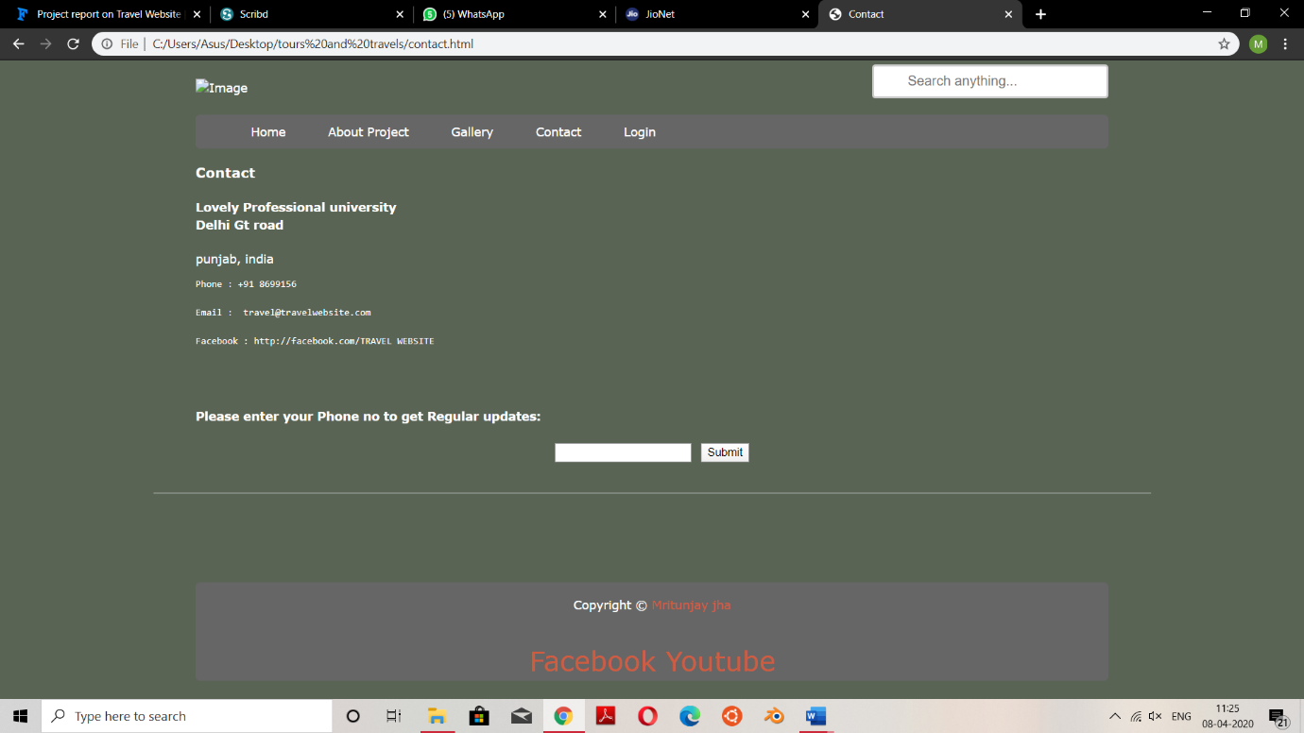

CONCLUSION

The project report entitled "COLLEGE WEBSITE CREATION" has come to its final stage. The system has been developed with much care that it is free of errors and at the same time it is efficient and less time consuming. The important thing is that the system is robust. We have tried our level best to make the site as dynamic as possible. Also provision is provided for future developments in the system. The entire system is secured.

Role of the students in the project

Mritunjay jha: I made the front end of the webpage in which I have taken help from internet.

ADABALA CHAITANYA SATYA VAMSI: he helped in making the login part and the contact part of the webpage.

KRISHNA TEJA SANISETTY: He helped us in collecting pictures of the website and helped in choosing the font.